**TASK 2.2P**

Screenshot of code running

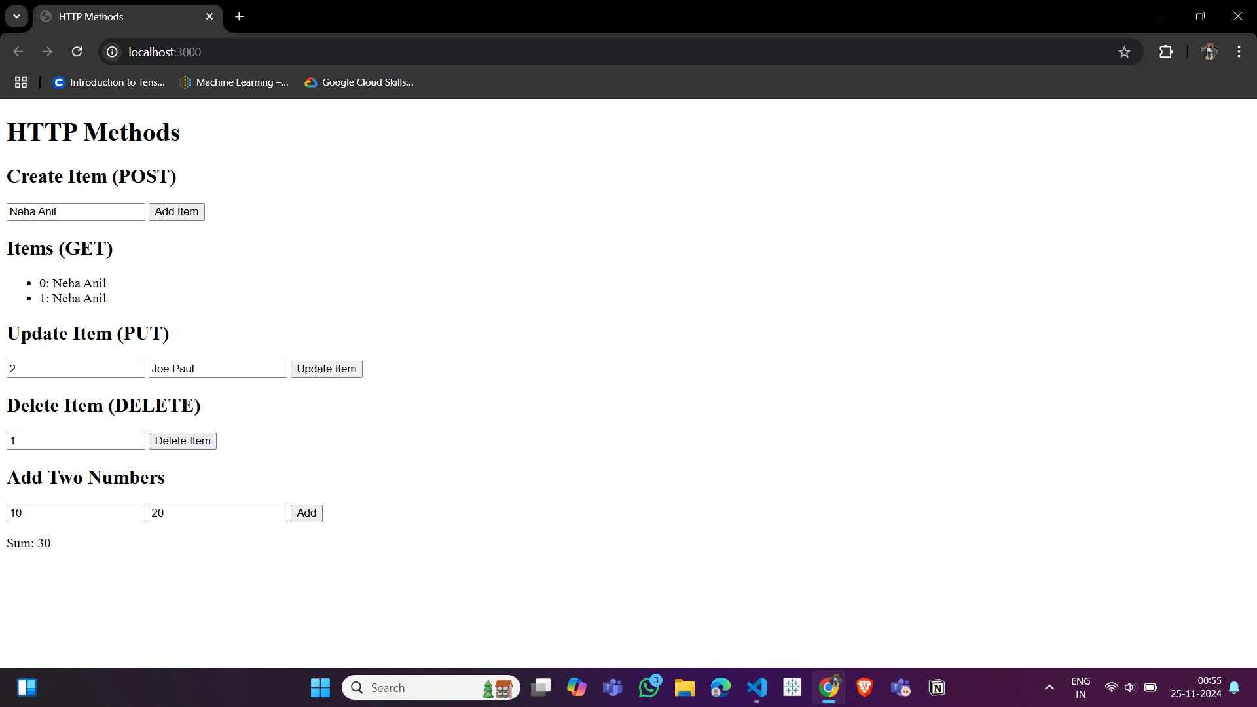

Repo link:

<https://github.com/nehaanil12345/SIT725.git>